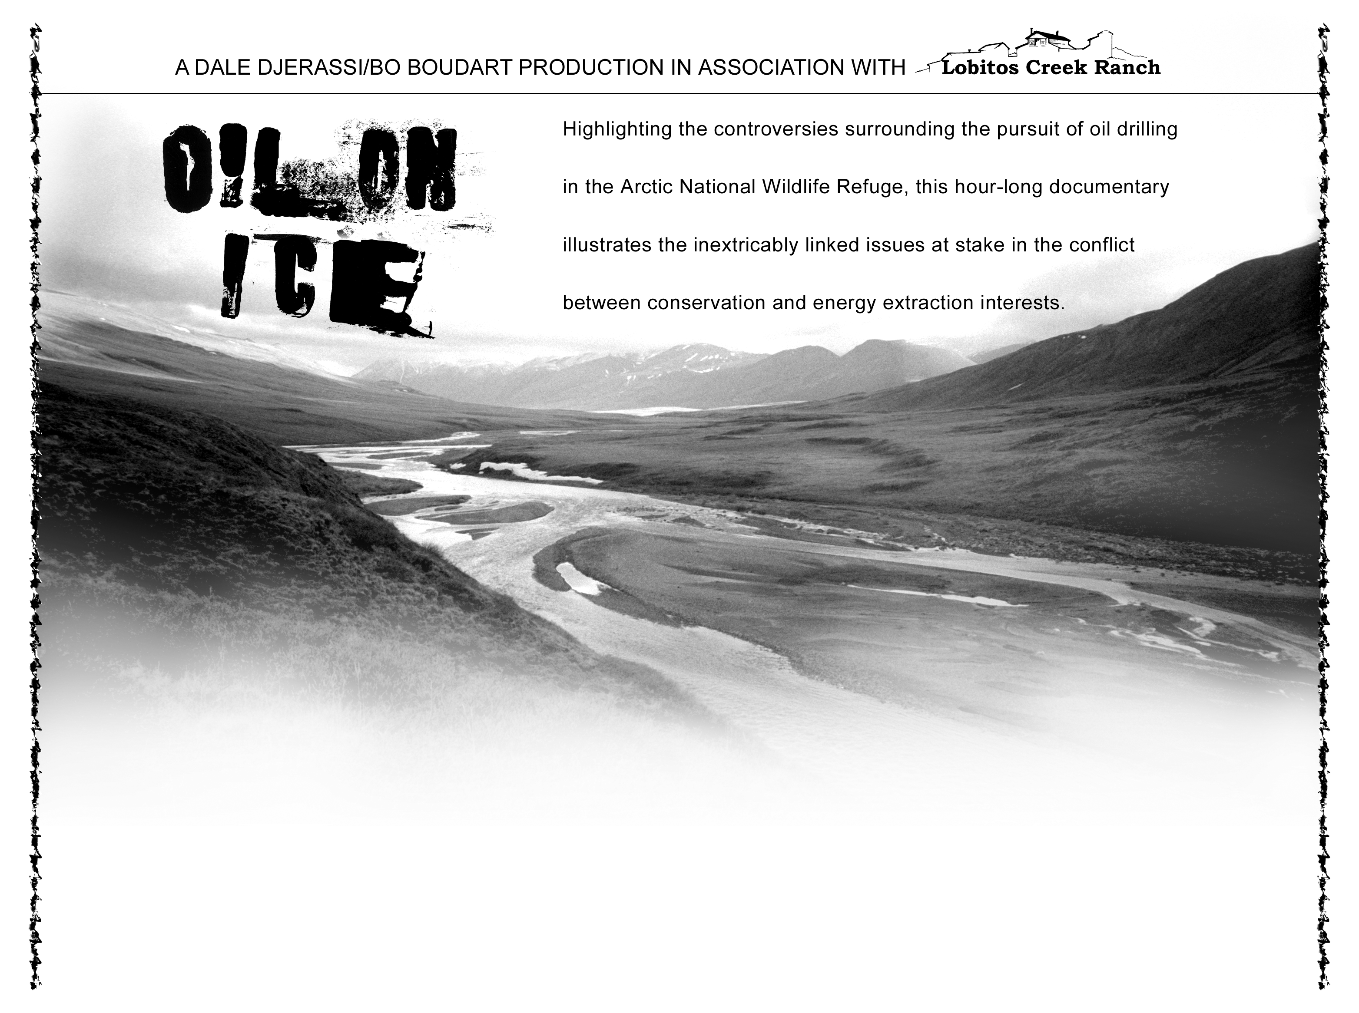
Oil on Ice Screening: Friday, October 22 @ 7 p.m.

Community Center
1010 Caribou Way
For more info, call: (213) 555-1234

